EN2550

Fundamentals of Image Processing and Machine vision

Assignment 01

Index Number: 190328V

Name: KUMARA B.W.J.C.

GitHub Link: <https://github.com/WikumJCK/EN2550_Image_Processessing.git>

**Question 01**

In intensity transformation, we enhance selected range of pixel vales, So, brightness of those pixels will increase. New features of the image can be obtained by this method. In the below, image of Emma Watson is enhanced according to the intensity transformation graph showed in figure 01, the result is pixels that are gray have enhanced so dark side of the face is lighted.

Fig 02

Fig 01

Using Look up tables to map the corresponding pixel values reduce the computational complexity of doing intensity transformation.

**Question 02**

In this Question we have enhance white matter and gray matter using intensity transformation. First, we must identify the range of pixel values we need to enhance to separate gray matter and white matter. For that I manually changed intensity transformation graph and selected suitable range.

Fig 03

Fig 03 represents original image and Gray and White matter enhanced image, Black color section represent white matter section while white color section represent gray matter section. Intensity transformation of the above image is shown in Fig 04.

Code used in this Question is same as Q01,

Fig 04

**Question 03**

Gamma correction is also a Intensity transformation, in this method intensity transformation is nonlinear. By changing gamma value, we can change the darkness of the image.

Fig 05

**Question 04**

In a picture, number of pixels with same intensity is not equal. Therefore for a normal image this histogram is not flat, the process of making the histogram flat is called histogram equalization. This results image being more vibrant. Here are the results(Fig 06),

Fig 06

This figure (Fig 07)shows histogram of two images before and after equalization.

Fig 07

**Question 05**

There are two methods to zoom an image, Nearest neighbor zooming and Bilinear interpolation. The more accurate one is using bilinear interpolation also it gives smoother image even if it is zoomed. But when we use Nearest neighbor zooming image get pixelated when size increased.

* Nearest neighbor zooming

Fig 09

Fig 08

Fig 08 shows original image and Fig 09 represent part of zoomed image, we can see that it is pixelated.

* Bilinear Interpolation

**Question 06**

In normal intensity transformation value of a pixel depended only on the same pixel. But, in Spatial filtering we consider neighbor pixels to calculate value to a pixel using a kernel. By using suitable kernel we can obtain blurred, Sobel horizontal and Soble vertical images. The data obtained from Soble filtering can be combined with original image to increase sharpness of the image. This figure(Fig 10) shows original image and Sobel filtered images

Fig 10

* Using inbuilt OpenCV function

* By defining own function

* By convolution

**Question 07**

Using inbuilt function grabCut in OpenCV library we can mask out specific object in defined area in our image. Also, we can remove the background of that image. In part (a) in this question we separate flower from the image. Masked foreground in background is showed in following figure.(Fig 11)

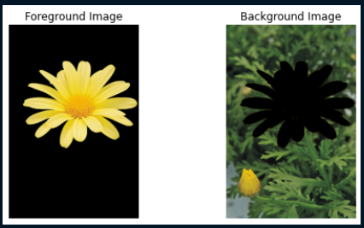

Fig 11

Masks of those two images are showed in below,

Fig 12

In part (b) of this question, first we blur the masked background of the image and combine it with masked foreground, then we can we that flower is focused.

